

CSE 523 Machine Learning

Progress Report - 6

Section 1

Date of Submission: 30th March 2022

Group Name: **Bug Smashers**

Group Details

| Roll No | Name |
| --- | --- |
| AU1940028 | Moksh Doshi |
| AU1940120 | Jaimik Patel |
| AU1940130 | Nandish Patel |
| AU1940164 | Jenil Bagadiya |

2022 Winter Semester

# Tasks Performed in the week

* + Applied gaussian naive bayes algorithm to the processed dataset

# Outcomes of the tasks performed

* + Naive Bayes algorithm resulted in an accuracy of 71.911% which is marginally higher than that of KNN with K=100 i.e. 71%. Looking at all of the outcomes, Gaussian Naive Bayes doesn’t stand out in any significant way, i.e., the accuracy is within the margin of error.
  + 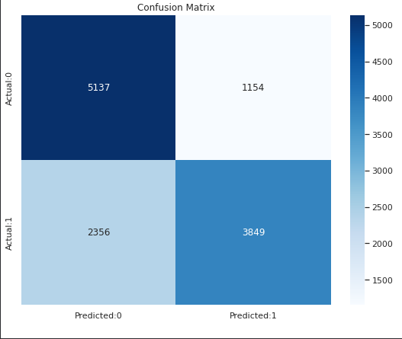
  + 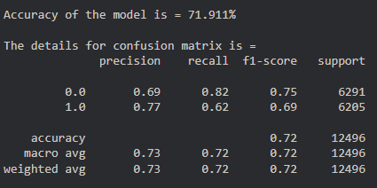

For gaussian naive bayes model

# Tasks to be performed in the upcoming week

* + Implementation few other classification algorithm like:
    1. Decision Tree
    2. SVM
    3. LDA